We’re providing two email scripts in this document; One is a template you can fill in with your details and the other is a sample. This file is a Word document so that you can easily copy and paste the script into your email.
Announcement Day Email

Instructions
The email script contains form fields you can easily fill out. Just click into a field and start typing. You can press the <TAB> key to move from one field to the next. After you’ve completed all of the fields, just copy the script and paste it into your email.
Each field has a help prompt associated with it you can see at the bottom of the screen:
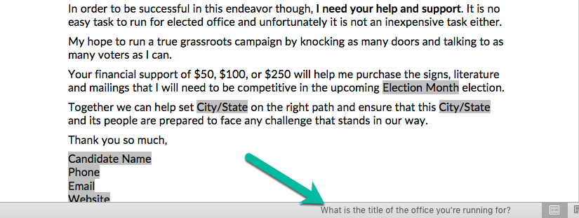
After you’re done editing the form, in order to copy the text you’ll need to turn off form protection. The “Protect Form” option is located on the Developer ribbon tab.
A few tips for your announcement email:
- Measure twice, cut once. This adage from the construction trade is good advice. You can’t un-send your email, so be sure that you’ve completed our pre-announcement checklist to be confident you’re prepared.
- If you’re using your personal email account (as opposed to a third-party tool like ActiveCampaign or Mailchimp), be sure to blind carbon-copy (BCC) the recipients. There are two reasons: First, people tend to get upset when their personal email address is revealed to a group of strangers. Second, it could aggravate recipients if people begin to “reply all” and they are suddenly sucked into an email chain.
- Spell check it! If you’re using Word, make sure the spell check feature is turned on.

Email Template
[Subject] It’s Official!
Friends and Family Members,
I'm writing you today to let you know that after much thought and consideration, I'm proud to announce that I have officially filed to run for Office Title.
This decision didn’t come lightly, and I'm very grateful for all the support and encouragement I’ve received from my friends, family, and members of the community.
I'm not a politician and I've never run for elected office before. I'm running for Office Title now, because I believe we need new and fresh ideas that come from a life time of experience. We need bold plans and elected officials who care more about doing what is best for the people of City/State than about getting reelected. I care deeply about the future of City/State and will work hard to do everything I can to improve it.
Point 1
Point 2
Point 3
In order to be successful in this endeavor though, I need your help and support. It is no easy task to run for elected office and unfortunately it is not an inexpensive task either.
My hope to run a true grassroots campaign by knocking as many doors and talking to as many voters as I can.
Your financial support of $50, $100, or $250 will help me purchase the signs, literature and mailings that I will need to be competitive in the upcoming Election Month election.
Together we can help set City/State on the right path and ensure that this City/State and its people are prepared to face any challenge that stands in our way.
Thank you so much,
Candidate Name
Phone
Email
Website

Sample Email
[Subject] It’s Official!
Friends and Family Members,
I'm writing you today to let you know that after much thought and consideration, I'm proud to announce that I have officially filed to run for State Representative in Montana’s 8th District.
This decision didn’t come lightly, and I'm very grateful for all the support and encouragement I’ve received from my friends, family, and members of the community.
I'm not a politician and I've never run for elected office before. I'm running for State Representative now, because I believe we need new and fresh ideas that come from a life time of experience. We need bold plans and elected officials who care more about doing what is best for the people of Montana than about getting reelected. I care deeply about the future of Montana and will work hard to do everything I can to improve it.
I believe that we need to make things in this state again, and the foundation of this starts with the way we teach our children. We need to focus on improving our public schools, and teach the young people of this state how to compete in the highly skilled and technical labor force that makes up Montana's 21st century economy. That means using technology in the classroom, and a return to vocational training.
I also believe that our state needs a real energy plan that works to lower costs while also preserving our environment. We need to find responsible energy projects that balance property rights, conservation concerns and the energy needs of our citizens and businesses.
Finally, we need to work to make this state more business friendly. Montana has one of the lowest job growth rates in the nation, and the state’s average age continues to climb. In order to attract new businesses, we need a favorable tax climate, cheaper and more predictable energy costs, and a skilled work force ready to fill the jobs they create. We can do all of these things if we are willing to work together.
In order to be successful in this endeavor though, I need your help and support. It is no easy task to run for elected office and unfortunately it is not an inexpensive task either.
My hope to run a true grassroots campaign by knocking as many doors and talking to as many voters as I can.
Your financial support of $50, $100, or $250 will help me purchase the signs, literature and mailings that I will need to be competitive in the upcoming March primary election.
Together we can help set Montana on the right path and ensure that this state and its people are prepared to face any challenge that stands in our way.
Thank you so much,
John Doe
(555) 555-5555
john.doe@gmail.com
www.johndoemontana.com

